Objective Questions

- Are there any tables with duplicate or missing null values? If so, how would you handle them?
Code:

-- check for null values in each table --
-- users
select * from users
where id is null
or username is null
or created_at is null;

-- photos
select * from photos
where id is null
or image_url is null
or user_id is null
or created_dat is null;

-- comments
select * from comments
where id is null
or comment_text is null
or user_id is null
or photo_id is null
or created_at is null;

-- likes
select * from likes
where user_id is null
or photo_id is null
or created_at is null;

-- follows
select * from follows
where follower_id is null
or followee_id is null
or created_at is null;

-- tags
select * from tags
where id is null
or tag_name is null
or created_at is null;

-- photo_tags
select * from photo_tags
where photo_id is null or tag_id is null;

Output:

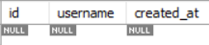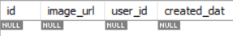

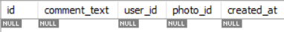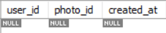

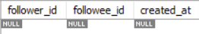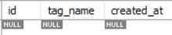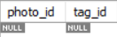

Explanation:

- The Instagram database was checked for duplicate records and missing (null) values to ensure the data is accurate and reliable for analysis.

- Tables such as likes, follows, and photo_tags use composite primary keys, while users and tags have unique constraints that help prevent duplicate entries.

- Most important columns are defined as NOT NULL, which helps minimize the chances of missing data.

- If duplicates or null values are found in future datasets, the duplicate records should first be verified and then removed if necessary. Missing values should be corrected using the original source data where possible; otherwise, the affected records can be excluded from the analysis to maintain data quality.

- What is the distribution of user activity levels (e.g., number of posts, likes, comments) across the user base?

Code:

select u.id, u.username, count(p.id) as total_posts
from users u
left join photos p
on u.id = p.user_id
group by u.id, u.username
order by total_posts desc;

Output:

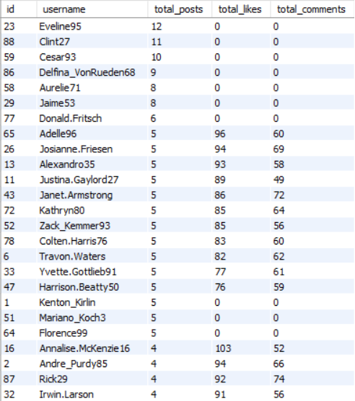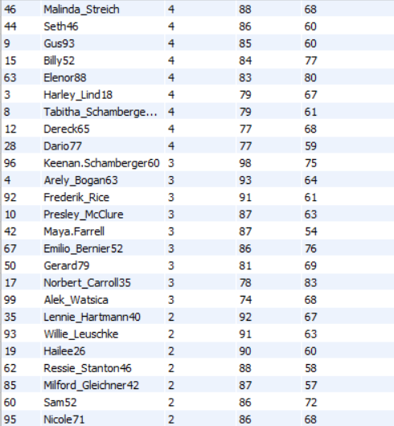

Visualization:

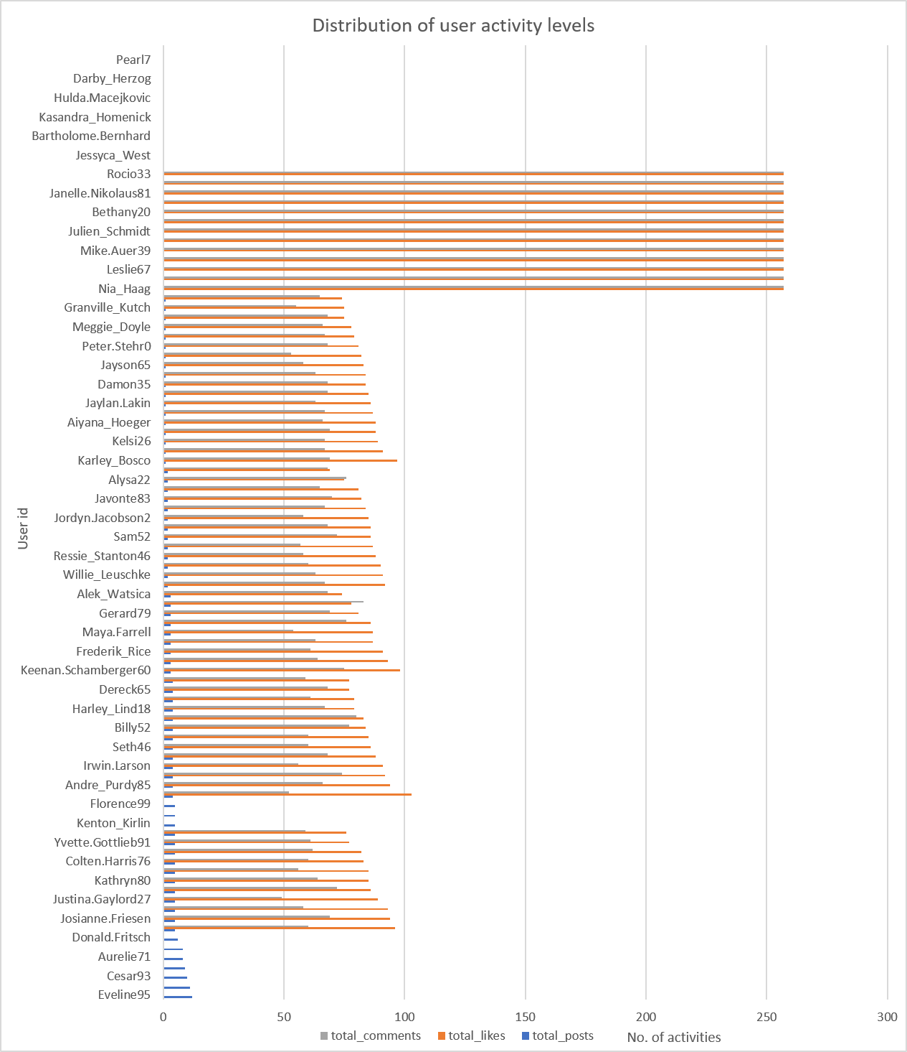
Explanation:

- The query measures user engagement by calculating the total posts created, likes given, and comments made by each user.

- A LEFT JOIN is used so that users with no activity are also included in the results.

- The data is arranged in descending order based on posts, likes, and comments to help identify the most active users on the platform.

- This analysis gives a better understanding of user participation and engagement across different activities.

- Calculate the average number of tags per post (photo_tags and photos tables).

Code:

select round(avg(tag_count), 2) as avg_tags_per_post
from ( select p.id as photo_id, count(pt.tag_id) as tag_count
from photos p
left join photo_tags pt on p.id = pt.photo_id
group by p.id
) as tags_per_post;

Output:

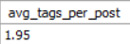

Visualization:
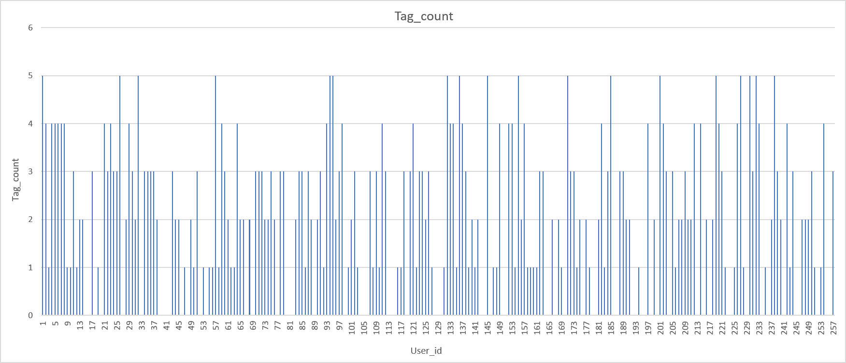

Explanation:

- The query calculates the average number of hashtags used for each photo by counting the hashtags linked to every photo.
- A LEFT JOIN is used so that photos with no hashtags are also included in the calculation.
- This gives a more accurate overall average of hashtags used per photo.
- This analysis helps understand how frequently users add hashtags to their photos and how they use hashtags when sharing content.

- Identify the top users with the highest engagement rates (likes, comments) on their posts and rank them.

Code:

with photo_count as (
select user_id, count(*) as total_posts
from photos
group by user_id
),
like_count as (
select p.user_id, count(*) as total_likes
from photos p
join likes l
on p.id = l.photo_id
group by p.user_id
),
comment_count as (
select p.user_id, count(*) as total_comments
from photos p
join comments c
on p.id = c.photo_id
group by p.user_id
)
select u.id, u.username, coalesce(pc.total_posts,0) as total_posts, coalesce(lc.total_likes,0) as total_likes,
coalesce(cc.total_comments,0) as total_comments
from users u
left join photo_count pc
on u.id = pc.user_id
left join like_count lc
on u.id = lc.user_id
left join comment_count cc
on u.id = cc.user_id
order by total_posts desc;

Output:

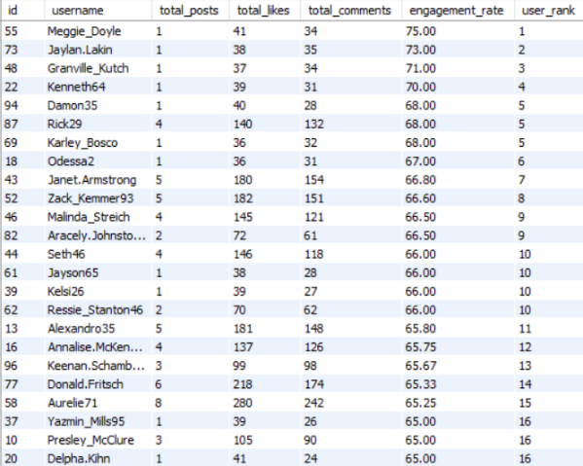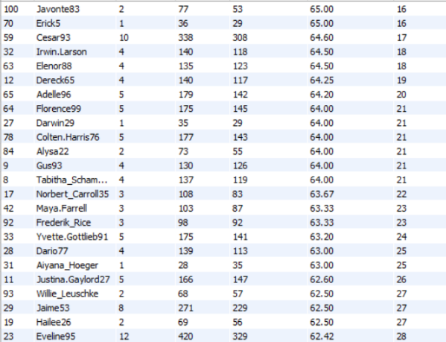

Visualization:

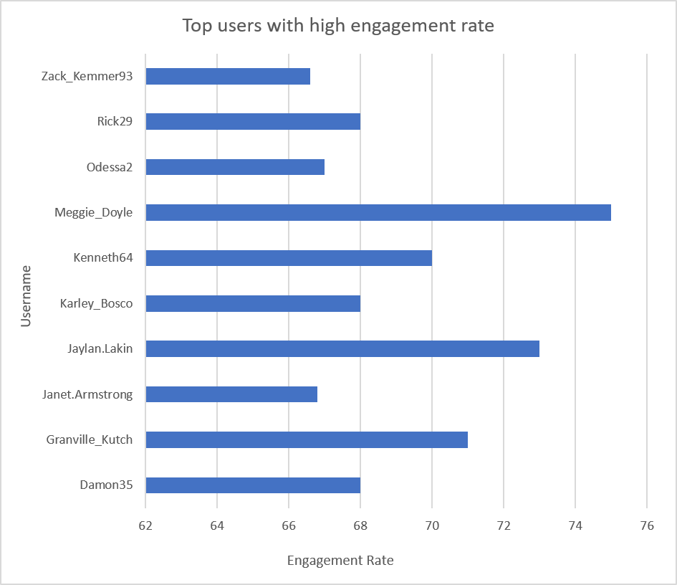
Explanation:

- The query finds users whose posts get the most engagement by adding the total likes and comments received and dividing them by the number of posts.
- The DENSE_RANK() function ranks users based on their engagement rate and gives the same rank to users with equal results.
- This analysis helps identify users who create highly engaging content and compares their performance based on audience interaction rather than just the number of posts.
- It gives a better understanding of which users receive more attention and interaction from their followers.
- The results can also help identify strong content creators who may have fewer posts but receive high engagement on each post.

- Which users have the highest number of followers and followings?

Code:

select t.tag_name, count(*) as total_usage
from photo_tags pt
join tags t
on pt.tag_id = t.id
group by t.id, t.tag_name
order by total_usage desc;

Output:

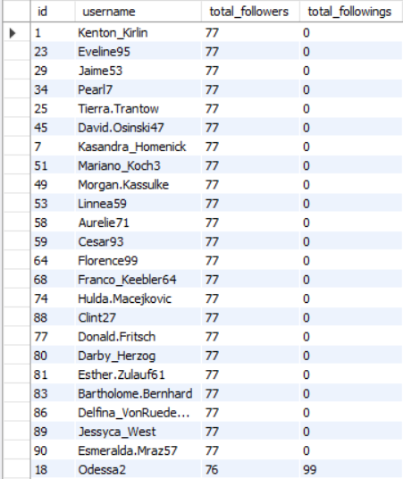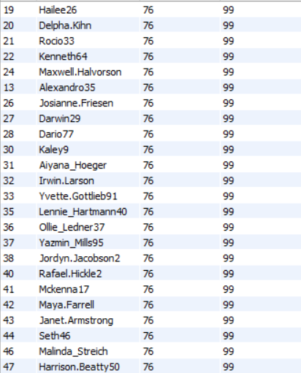

Visualization:

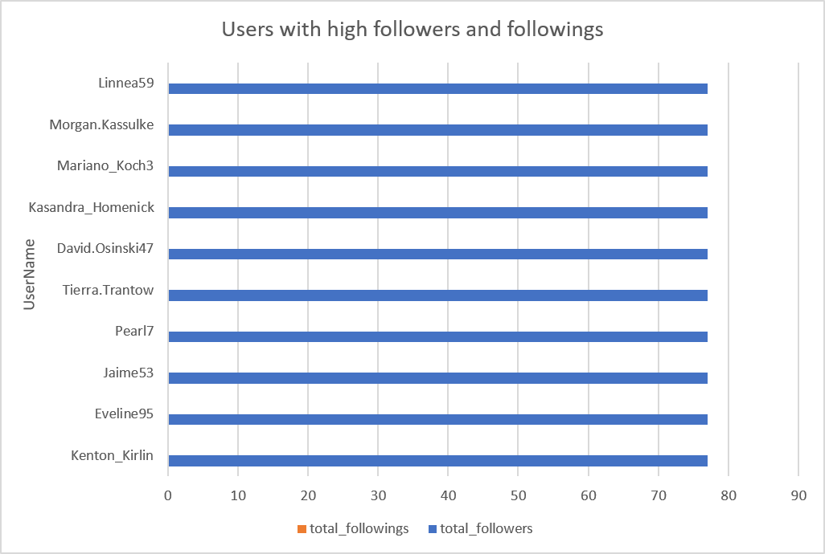

Explanation:

- This query calculates the total number of followers and followings for each user by aggregating the follows table separately for both relationships.
- The coalesce() function ensures users without followers or followings are displayed with a value of zero.
- The results are sorted by the highest follower count, making it easy to identify the most popular users on the platform while also showing how actively they follow others.

- Calculate the average engagement rate (likes, comments) per post for each user.

Code:

with likes_per_user as (
select p.user_id, count(*) as total_likes
from photos p
join likes l
on p.id = l.photo_id
group by p.user_id
),
comments_per_user as (
select p.user_id, count(*) as total_comments
from photos p
join comments c
on p.id = c.photo_id
group by p.user_id
)
select u.id, u.username, coalesce(l.total_likes,0) as total_likes, coalesce(c.total_comments,0) as total_comments,
coalesce(l.total_likes,0) + coalesce(c.total_comments,0) as total_engagement
from users u
left join likes_per_user l
on u.id = l.user_id
left join comments_per_user c
on u.id = c.user_id
order by total_engagement desc;

Output:

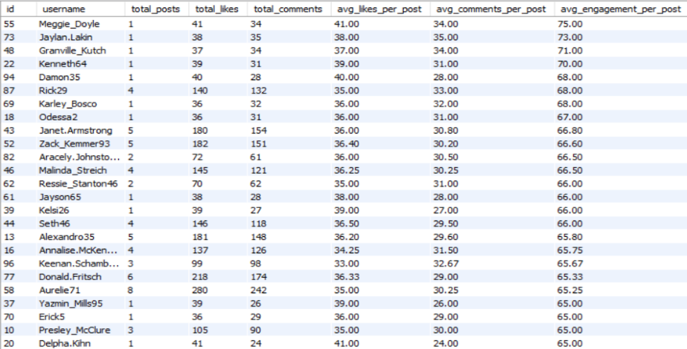

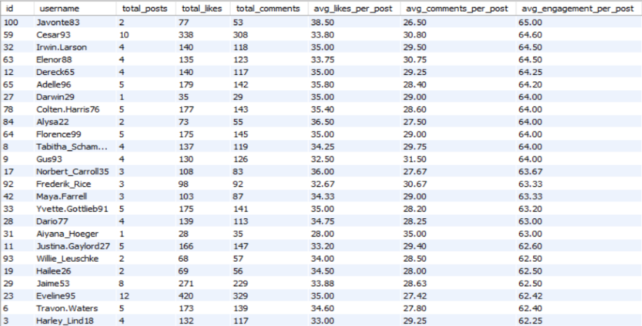

Visualization:

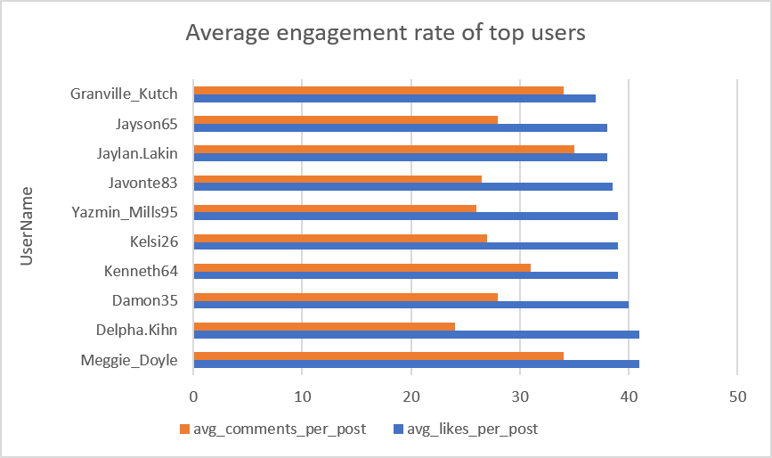

Explanation:

- The query calculates the average engagement of each user's posts by finding the average number of likes and comments received per post.
- It shows separate averages for likes and comments along with the overall engagement rate, making it easier to compare users even if they have posted different numbers of photos.
- Users with higher average engagement usually create content that gets more interest and interaction from their audience.
- This analysis helps identify users whose posts perform well based on the response they receive from other users.
- It can also help understand which type of users are consistently getting good engagement on their posts.

- Get the list of users who have never liked any post (users and likes tables)

Code:

select u.id, u.username
from users u
left join likes l on u.id = l.user_id
where l.user_id is null
order by u.username;

Output:

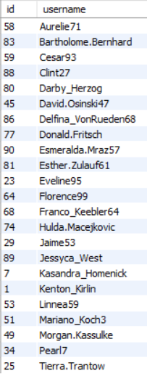

Explanation:

- This query identifies users who have never liked any post by comparing the users and likes tables using a LEFT JOIN.
- These users may be new to the platform or less active and may not have started interacting with posts yet.
- Finding these users can help the marketing team target them with re-engagement campaigns, personalized suggestions, or other strategies.
- This analysis can also help understand how many users are not actively participating through likes.
- It may help the platform improve user engagement by encouraging inactive users to interact more with the content.

- How can you leverage user-generated content (posts, hashtags, photo tags) to create more personalized and engaging ad campaigns?

Code:

select t.tag_name, count(pt.photo_id) as total_usage
from tags t
join photo_tags pt on t.id = pt.tag_id
group by t.id, t.tag_name
order by total_usage desc;

Output:
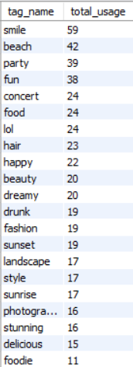

Visualization:

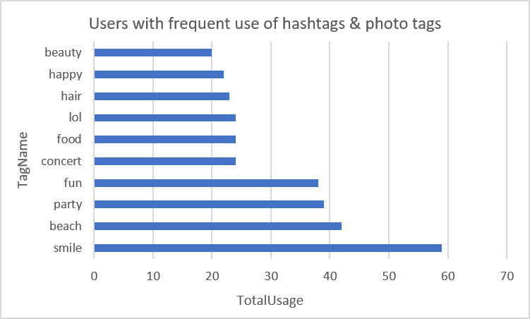

Explanation:

- This query finds the most commonly used hashtags by counting how many times each hashtag is used in photos.
- Frequently used hashtags can show popular topics and common interests among users.
- The marketing team can use this information to create better advertising campaigns and recommend relevant content to users.
- Using popular hashtags can help increase user engagement and make promotional content more relevant.
- This analysis can also help identify trending topics and understand what type of content is currently getting more attention on the platform.

- Are there any correlations between user activity levels and specific content types (e.g., photos, videos, reels)? How can this information guide content creation and curation strategies?

Code:

with engagement as (
select p.user_id, count(l.photo_id) as likes, count(c.id) as comments
from photos p
left join likes l
on p.id = l.photo_id
left join comments c
on p.id = c.photo_id
group by p.user_id
)
select u.username, coalesce(e.likes,0) as likes, coalesce(e.comments,0) as comments,
coalesce(e.likes,0) + coalesce(e.comments,0) as total_engagement
from users u
left join engagement e
on u.id = e.user_id
order by total_engagement desc;

Output:

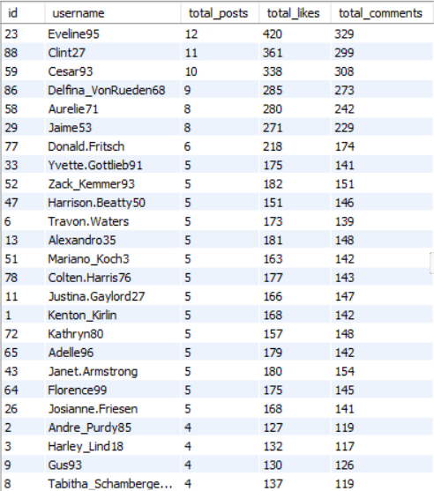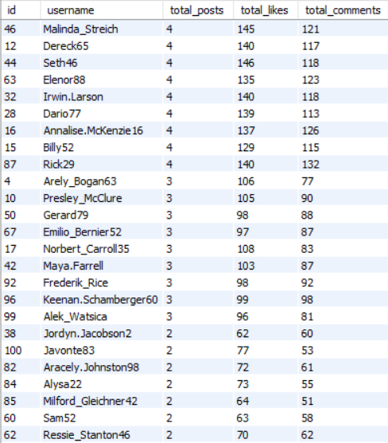

Visualization:

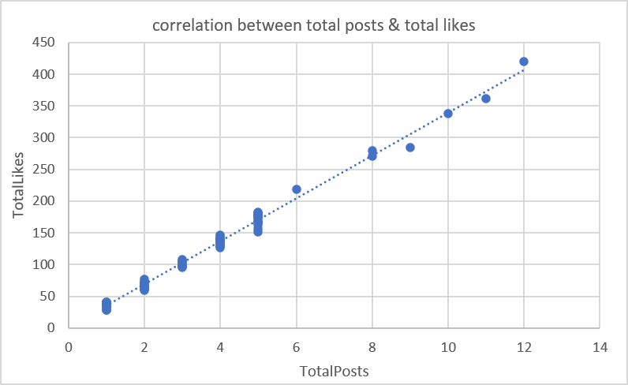

Explanation:

- A direct comparison across content types is not possible because the available dataset includes only photo posts and does not distinguish among photos, videos, or reels.
- Therefore, this analysis examines the relationship between users’ posting activity and the engagement their posts receive through likes and comments.
- If users with more posts consistently receive higher engagement, it suggests that regular content creation contributes to greater audience interaction.
- These insights can help guide content scheduling, improve posting strategies, and encourage creators to maintain consistent activity.

- Calculate the total number of likes, comments, and photo tags for each user.

Code:

with likes_per_user as (
select p.user_id, count(*) as total_likes
from photos p
join likes l
on p.id = l.photo_id
group by p.user_id
),
comments_per_user as (
select p.user_id, count(*) as total_comments
from photos p
join comments c
on p.id = c.photo_id
group by p.user_id
),
tags_per_user as (
select p.user_id, count(*) as total_photo_tags
from photos p
join photo_tags pt
on p.id = pt.photo_id
group by p.user_id
)
select u.id, u.username, coalesce(l.total_likes, 0) as total_likes,
coalesce(c.total_comments, 0) as total_comments, coalesce(t.total_photo_tags, 0) as total_photo_tags
from users u
left join likes_per_user l
on u.id = l.user_id
left join comments_per_user c
on u.id = c.user_id
left join tags_per_user t
on u.id = t.user_id
order by total_likes desc, total_comments desc, total_photo_tags desc;

Output:

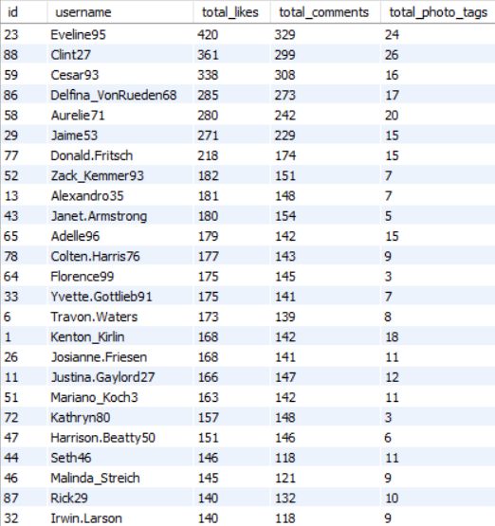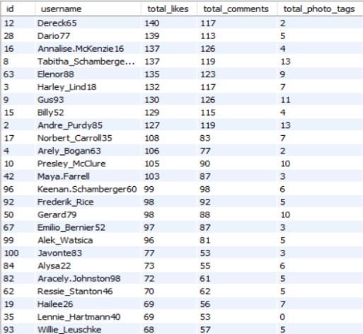

Visualization:

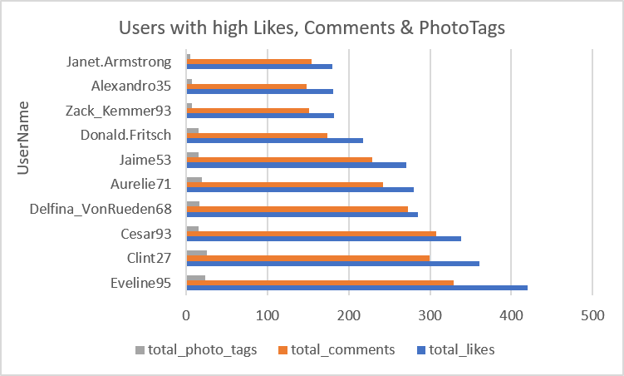

Explanation:

- This query summarizes user engagement by calculating the total number of likes, comments, and photo tags associated with each user's posts.
- These metrics provide a comprehensive view of how users interact with content and how frequently tags are used to categorize posts.
- Users with high values across these metrics generally produce more engaging and discoverable content.
- These insights can help marketing teams identify influential users, evaluate content performance, and improve content recommendation and promotional strategies.

- Rank users based on their total engagement (likes, comments, shares) over a month.

Code:

with engagement as (
select p.user_id, count(l.photo_id) as total_likes, count(c.id) as total_comments,
count(l.photo_id) + count(c.id) as total_engagement
from photos p
left join likes l
on p.id = l.photo_id
left join comments c
on p.id = c.photo_id
group by p.user_id
)
select u.id, u.username, coalesce(e.total_likes, 0) as total_likes,
coalesce(e.total_comments, 0) as total_comments, coalesce(e.total_engagement, 0) as total_engagement,
dense_rank() over (order by coalesce(e.total_engagement, 0) desc) as engagement_rank
from users u
left join engagement e
on u.id = e.user_id
order by engagement_rank;

Output:

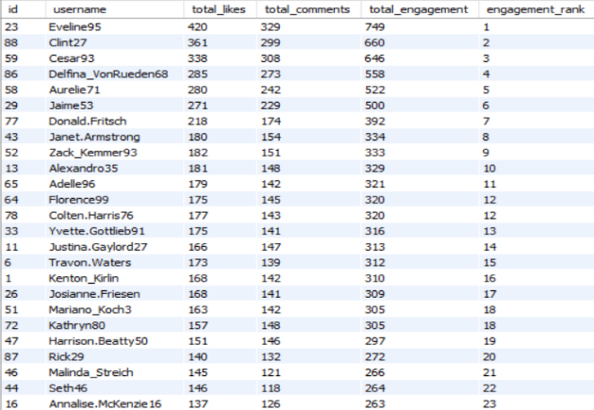
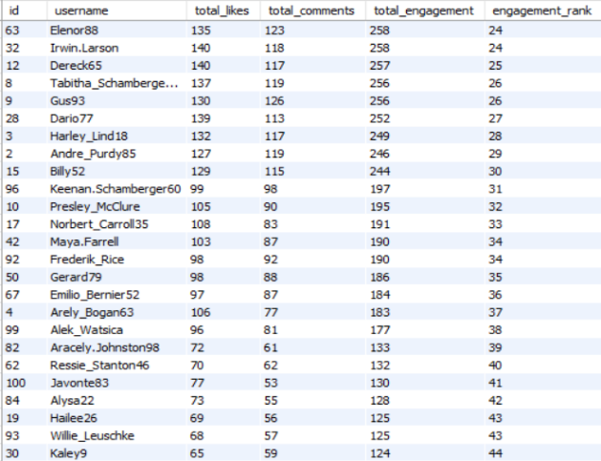

Visualization:

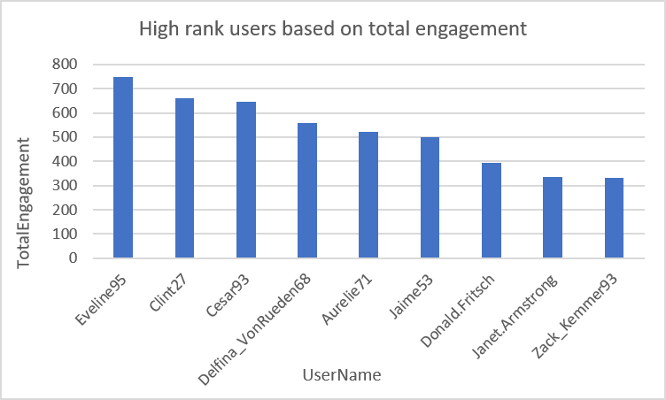

Explanation:

- This query ranks users based on the total engagement received on their posts by combining the number of likes and comments.
- Since the dataset does not include post shares, engagement is calculated using only the available metrics.
- The dense_rank() function assigns rankings while handling ties appropriately.
- Users with higher engagement are likely to create content that attracts greater audience interaction.
- These rankings help identify highly influential users who can be considered for promotional campaigns, featured content, or community engagement initiatives.

- Retrieve the hashtags that have been used in posts with the highest average number of likes. Use a CTE to calculate the average likes for each hashtag first.

Code:

with hashtag_likes as (
select t.id as tag_id, t.tag_name, p.id as photo_id, count(distinct l.user_id, l.photo_id) as total_likes
from tags t
inner join photo_tags pt on t.id = pt.tag_id
inner join photos p on pt.photo_id = p.id
left join likes l on p.id = l.photo_id
group by t.id, t.tag_name, p.id
)
select tag_name, round(avg(total_likes), 2) as avg_likes
from hashtag_likes
group by tag_id, tag_name
order by avg_likes desc;

Output:

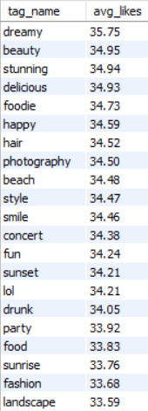

Visualization:

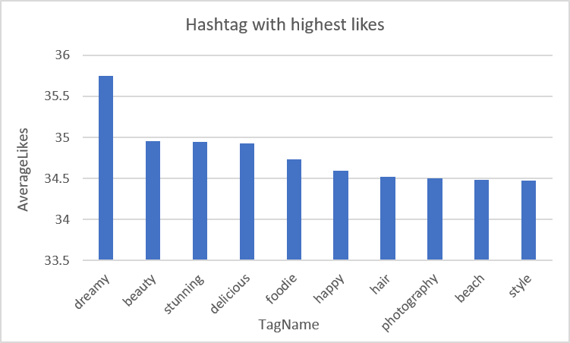

Explanation:

- This query first uses a CTE to calculate the number of likes received by each photo that has a hashtag.
- It then calculates the average likes for each hashtag and ranks them based on their average engagement.
- Hashtags with higher average likes show topics or content that receive more attention from users.
- This information can help the marketing team find popular content categories and create better hashtag strategies and targeted campaigns.
- It can also help identify which hashtags are more likely to increase engagement and attract users' attention.
- The results can be useful for understanding trending content and improving future marketing decisions.

- Retrieve the users who have started following someone after being followed by that person

Code:

select u1.username as user_1, u2.username as user_2
from follows f1
inner join follows f2 on f1.follower_id = f2.followee_id and f1.followee_id = f2.follower_id
inner join users u1 on f1.follower_id = u1.id
inner join users u2 on f1.followee_id = u2.id
where f1.follower_id < f1.followee_id
order by user_1, user_2;

Output:

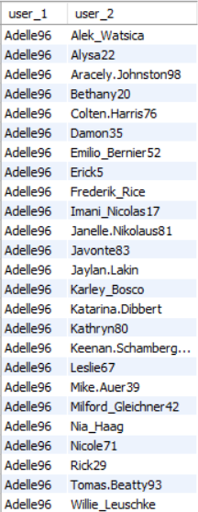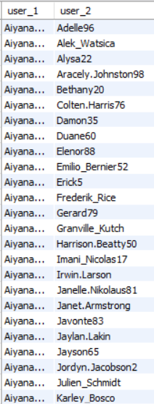

Explanation:

- This query identifies users who follow each other by finding reciprocal relationships in the follows table.
- Such mutual connections often indicate stronger social relationships and higher user engagement within the platform.
- The query self-joins the follows table to detect two-way follow relationships and lists each pair only once to avoid duplication.
- These insights can help social media platforms recommend friends, strengthen community-building features, and analyze user interaction patterns more effectively.
Subjective Questions

- Based on user engagement and activity levels, which users would you consider the most loyal or valuable? How would you reward or incentivize these users?

Code:

with post_count as (
select user_id, count(*) as total_posts
from photos
group by user_id
),
like_count as (
select p.user_id, count(*) as total_likes
from photos p
join likes l
on p.id = l.photo_id
group by p.user_id
),
comment_count as (
select p.user_id, count(*) as total_comments
from photos p
join comments c
on p.id = c.photo_id
group by p.user_id
)
select u.id, u.username, coalesce(pc.total_posts,0) as total_posts,
coalesce(lc.total_likes,0) as total_likes, coalesce(cc.total_comments,0) as total_comments,
round((coalesce(lc.total_likes,0) + coalesce(cc.total_comments,0)) / nullif(coalesce(pc.total_posts,0),0),2) as engagement_per_post
from users u
left join post_count pc
on u.id = pc.user_id
left join like_count lc
on u.id = lc.user_id
left join comment_count cc
on u.id = cc.user_id
where coalesce(pc.total_posts,0) > 0
order by engagement_per_post desc, total_posts desc;

Output:

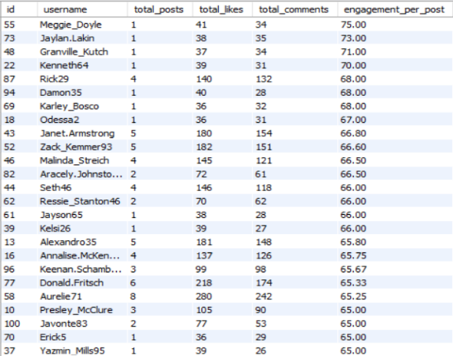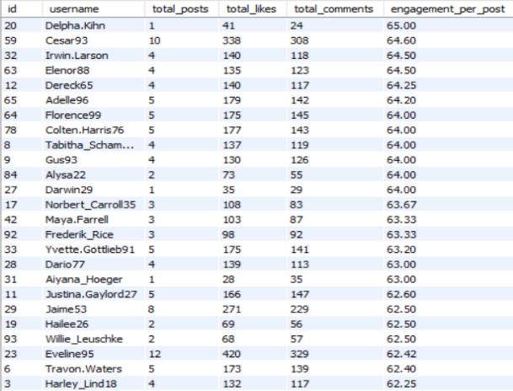

Visualization:

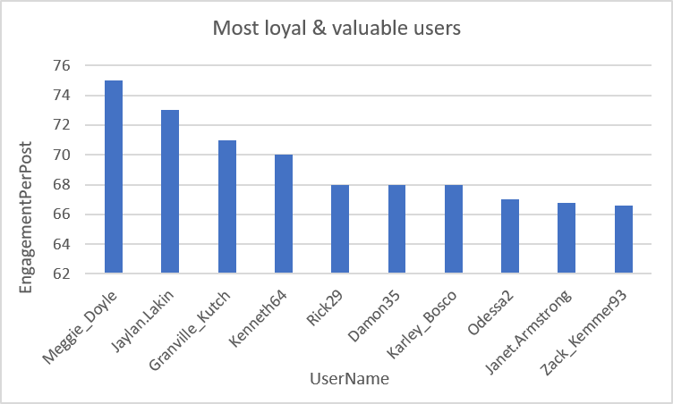
Approach:

- To find the most valuable and loyal users, both their posting activity and the engagement they receive were analyzed.
- User activity was measured by the total number of posts, while engagement was based on the likes and comments received on those posts.
- An engagement-per-post value was calculated to make a fair comparison between users who post more or fewer times.
- This approach helps identify users who create content that gets strong audience interaction, instead of only focusing on users who post frequently.

Insights:

- Users with high engagement per post can be considered some of the most valuable content creators on the platform.
- Some users may post less often but still receive a large number of likes and comments, showing that their content is popular with the audience.
- Users who post regularly and receive good engagement can provide long-term value to the platform.
- These users can help increase overall activity by encouraging other users to like, comment, and interact with their content.
- They can also be good candidates for creator programs, collaborations, and promotional activities because they already have an active audience.

Recommendations:

- Create a Creator Rewards Program to recognize users with high engagement through badges, special features, or other rewards.
- Give active creators early access to new features so they can try and promote them before wider release.
- Provide opportunities for brand collaborations, sponsored content, and other creator partnerships.
- Promote high-performing posts through recommendations and featured content to increase their reach.
- Offer personalized rewards such as milestones, promotional benefits, or invitations to special events to encourage users to stay active.
- Regularly track engagement levels to find new creators and support them before their engagement starts to decrease.

- For inactive users, what strategies would you recommend to re-engage them and encourage them to start posting or engaging again?

Code:

select u.id, u.username, count(distinct p.id) as total_posts, count(distinct l.photo_id) as total_likes,
count(distinct c.id) as total_comments
from users u
left join photos p on u.id = p.user_id
left join likes l on u.id = l.user_id
left join comments c on u.id = c.user_id
group by u.id, u.username
having total_posts = 0 and total_likes = 0 and total_comments = 0
order by u.username;

Output:

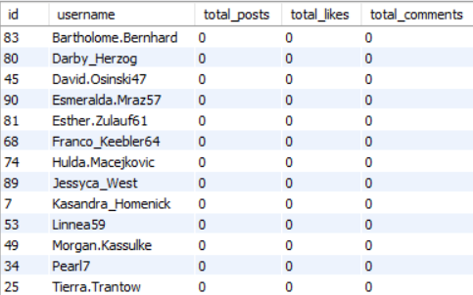
Approach:

- The analysis finds inactive users by looking at three main activities: posts created, likes given, and comments made.
- Users with no posts, likes, or comments are considered inactive because they have not created content or interacted with others.
- These users can be targeted through re-engagement activities to encourage them to become active again.
- This analysis also helps the platform understand how many users are inactive and where more engagement may be needed.

Insights:

- Inactive users have little or no activity on the platform.
- Some users may have created an account but never started using the platform regularly.
- Bringing back existing inactive users can be useful because it may be easier than attracting completely new users.
- Personalized messages and content suggestions may encourage these users to return and interact.
- Studying inactive users can also help the platform improve the signup and onboarding process.
- Identifying the reasons behind inactivity can help reduce the number of users who stop using the platform in the future.

Recommendations:

- Send personalized notifications or emails to remind inactive users to explore new posts and connect with other users.
- Offer simple rewards, badges, or limited-time incentives to encourage users to make their first post, like, or comment after returning.
- Recommend popular creators, hashtags, and relevant content based on the user's interests.
- Make the onboarding process easier by providing simple guides and tips for new users.
- Introduce challenges, contests, or referral activities to encourage inactive users to participate.
- Track user activity after each re-engagement campaign to see which strategies are working best.
- Use the results to improve future campaigns and encourage inactive users to remain active on the platform.

- Which hashtags or content topics have the highest engagement rates? How can this information guide content strategy and ad campaigns?

Code:

with photo_engagement as (
select p.id as photo_id, count(distinct l.user_id, l.photo_id) as total_likes, count(distinct c.id) as total_comments
from photos p
left join likes l
on p.id = l.photo_id
left join comments c
on p.id = c.photo_id
group by p.id
)
select t.tag_name, round(avg(coalesce(pe.total_likes, 0)), 2) as avg_likes, round(avg(coalesce(pe.total_comments, 0)), 2) as avg_comments,
round(avg(coalesce(pe.total_likes, 0) + coalesce(pe.total_comments, 0)), 2) as avg_engagement
from tags t
join photo_tags pt
on t.id = pt.tag_id
left join photo_engagement pe
on pt.photo_id = pe.photo_id
group by t.id, t.tag_name
order by avg_engagement desc;

Output:

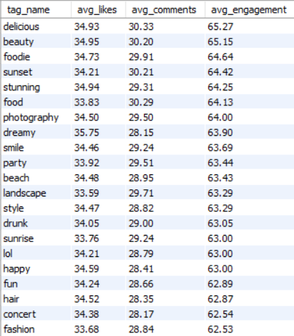

Visualization:

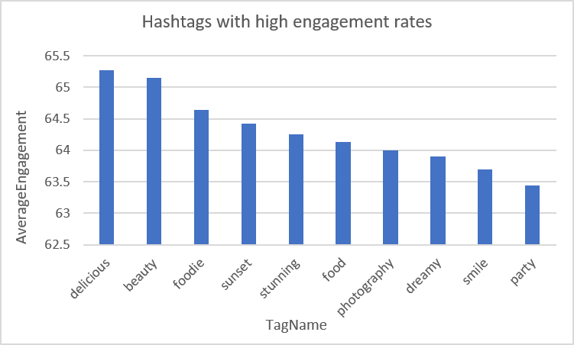

Approach:

- The analysis combines hashtag information with likes and comments received on tagged photos to measure engagement for each hashtag.
- A Common Table Expression (CTE) is used to calculate engagement at the photo level before averaging it across all posts containing the same hashtag.
- This approach identifies hashtags that consistently attract audience interaction rather than those that are simply used most frequently.
- Ranking hashtags by average engagement helps identify content themes that perform best on the platform.

Insights:

- High-engagement hashtags represent content topics that consistently capture users' attention.
- Some hashtags may appear less frequently but generate significantly higher engagement than widely used hashtags, indicating high-quality niche interests.
- Using engagement rate instead of usage count provides a better measure of content effectiveness.
- Identifying top-performing hashtags enables marketers to understand audience preferences and improve content discovery.
- These insights help prioritize topics that are more likely to generate meaningful interactions and increase organic reach.

Recommendations:

- Encourage creators to use high-performing hashtags in their posts to improve visibility and engagement.
- Design marketing campaigns around trending content themes identified through hashtag analysis.
- Recommend personalized hashtags to users based on their posting history and interests.
- Continuously monitor hashtag performance, as audience preferences can change over time.
- Combine high-engagement hashtags with seasonal or campaign-specific hashtags to maximize reach.
- Use these insights to improve Instagram's recommendation algorithm and optimize sponsored content targeting.

- Are there any patterns or trends in user engagement based on demographics (age, location, gender) or posting times? How can these insights inform targeted marketing campaigns?

Code:

select u.id, u.username, count(distinct p.id) as total_posts,
count(distinct l.user_id, l.photo_id) as total_likes, count(distinct c.id) as total_comments,
round((count(distinct l.user_id, l.photo_id) + count(distinct c.id)) / nullif(count(distinct p.id),0), 2) as engagement_per_post
from users u
left join photos p on u.id = p.user_id
left join likes l on p.id = l.photo_id
left join comments c on p.id = c.photo_id
group by u.id, u.username
having total_posts > 0
order by engagement_per_post desc;

Output:

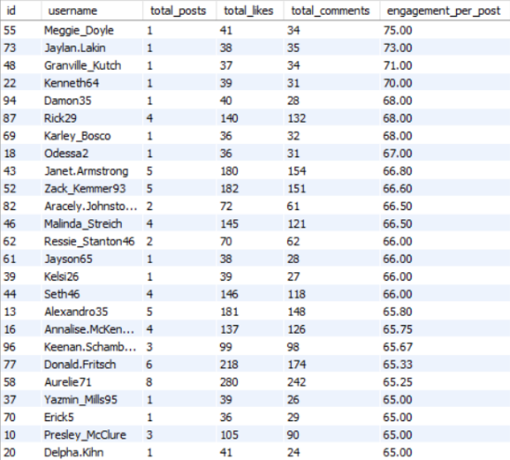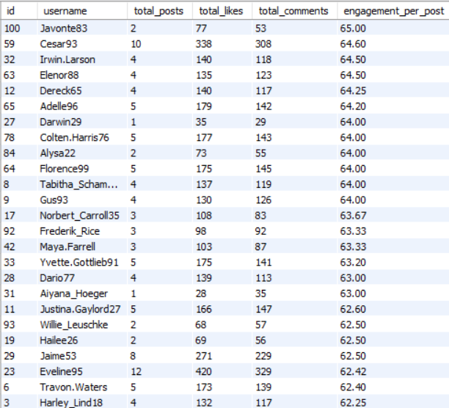

Visualization:

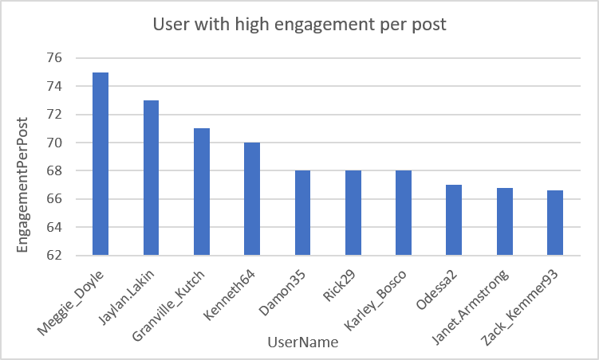

Approach:

- The project question requests an analysis based on demographics and posting time.
- However, the available dataset does not include demographic attributes such as age, gender, or location, nor does it contain posting timestamps for photos.
- As a result, the analysis focuses on overall user engagement by measuring posts, likes, comments, and engagement per post.
- This provides an alternative way to understand user behavior while ensuring that conclusions are supported by the available data.

Insights:

- The dataset does not support demographic or posting-time analysis because the required attributes are unavailable.
- Users with higher engagement per post consistently produce content that attracts more audience interaction.
- Posting frequency alone does not guarantee high engagement, indicating that content quality likely has a significant impact.
- Additional demographic and temporal data would enable more accurate audience segmentation and campaign optimization.
- Even with the current dataset, engagement metrics help identify users whose content performs well.

Recommendations:

- Collect demographic information such as age, gender, and location (while complying with privacy regulations) to enable audience segmentation.
- Store photo posting timestamps to determine the best days and times for publishing content.
- Analyze engagement trends across different demographic groups to personalize recommendations and advertisements.
- Schedule promotional campaigns during peak engagement periods identified through posting-time analysis.
- Combine demographic insights with engagement metrics to improve content recommendations and targeted marketing campaigns.

- Based on follower counts and engagement rates, which users would be ideal candidates for influencer marketing campaigns? How would you approach and collaborate with these influencers?

Code:

select u.id, u.username, coalesce(f.total_followers, 0) as total_followers, coalesce(p.total_posts, 0) as total_posts,
coalesce(l.total_likes, 0) as total_likes, coalesce(c.total_comments, 0) as total_comments,
round((coalesce(l.total_likes, 0) + coalesce(c.total_comments, 0)) / nullif(coalesce(p.total_posts, 0), 0), 2) as engagement_per_post
from users u
left join (
select followee_id, count(*) as total_followers
from follows
group by followee_id
) f on u.id = f.followee_id
left join (
select user_id, count(*) as total_posts
from photos
group by user_id
) p on u.id = p.user_id
left join (
select p.user_id, count(*) as total_likes
from photos p
inner join likes l on p.id = l.photo_id
group by p.user_id
) l on u.id = l.user_id
left join (
select p.user_id, count(*) as total_comments
from photos p
inner join comments c on p.id = c.photo_id
group by p.user_id
) c on u.id = c.user_id
where coalesce(p.total_posts, 0) > 0
order by total_followers desc, engagement_per_post desc;

Output:

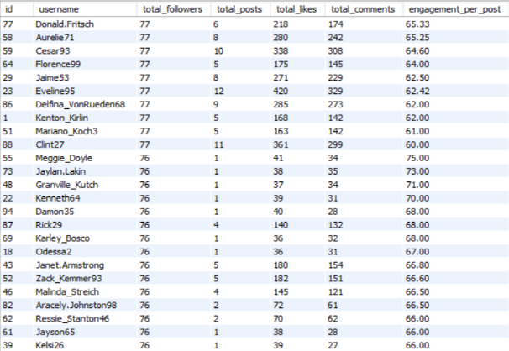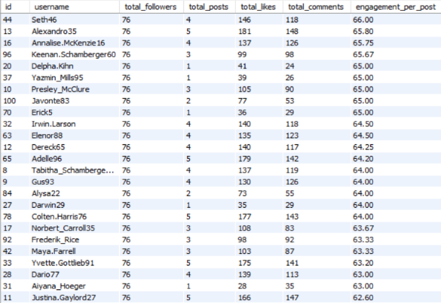
Visualization:

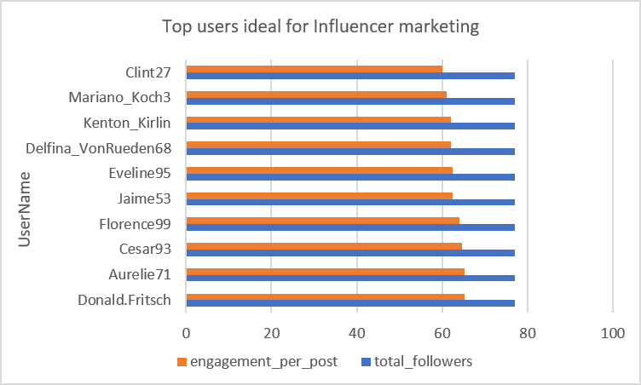

Approach:

- To find suitable influencers, two main factors were considered: the number of followers and engagement per post.
- Follower count shows how large the creator's audience is, while engagement per post shows how actively followers interact with their content.
- Looking at both metrics helps identify creators who have good audience reach as well as strong interaction.
- Users with high followers and high engagement can be considered strong candidates for influencer marketing.
- This approach also helps compare creators more fairly instead of selecting influencers based only on their follower count.

Insights:

- Users with a large number of followers and consistently high engagement are strong choices for influencer campaigns.

- High engagement can show that followers are interested in the creator's content and trust their recommendations.
- Some users may have fewer followers but very high engagement, making them useful as micro-influencers.
- Looking only at follower count may miss creators who have smaller but more active audiences.
|
- Comparing both reach and engagement gives a better understanding of an influencer's overall value.
- Creators with consistent engagement can potentially provide better results and stronger connections with their audience.

Recommendations:

- Focus on users who have both a strong follower base and good engagement when selecting influencers.
- Create personalized collaboration opportunities such as sponsored posts, product promotions, live sessions, and special campaigns.
- Consider working with micro-influencers who have smaller audiences but consistently receive high engagement.
- Measure campaign results using engagement rate, clicks, conversions, and other performance metrics.
- Build long-term relationships with successful influencers to maintain audience interest and improve brand visibility.
- Regularly review influencer performance to identify new creators who may become valuable marketing partners in the future.

- Based on user behavior and engagement data, how would you segment the user base for targeted marketing campaigns or personalized recommendations?

Code:

select u.id, u.username, count(distinct p.id) as total_posts,
count(distinct l.photo_id) as total_likes_given, count(distinct c.id) as total_comments,
case
when count(distinct p.id) >= 5 then 'content creator'
when count(distinct l.photo_id) >= 5 or count(distinct c.id) >= 5 then 'active engager'
when count(distinct p.id) = 0 and count(distinct l.photo_id) = 0 and count(distinct c.id) = 0 then 'inactive user'
else 'casual user'
end as user_segment
from users u
left join photos p on u.id = p.user_id
left join likes l on u.id = l.user_id
left join comments c on u.id = c.user_id
group by u.id, u.username
order by user_segment, total_posts desc;

Output:

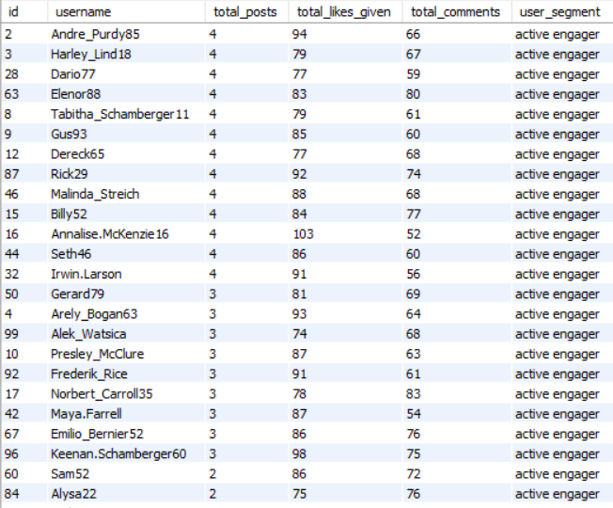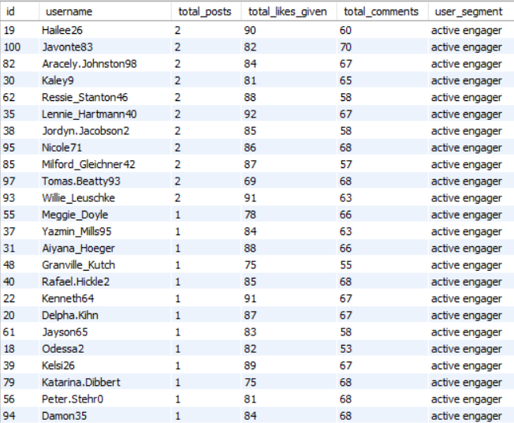

Visualization:

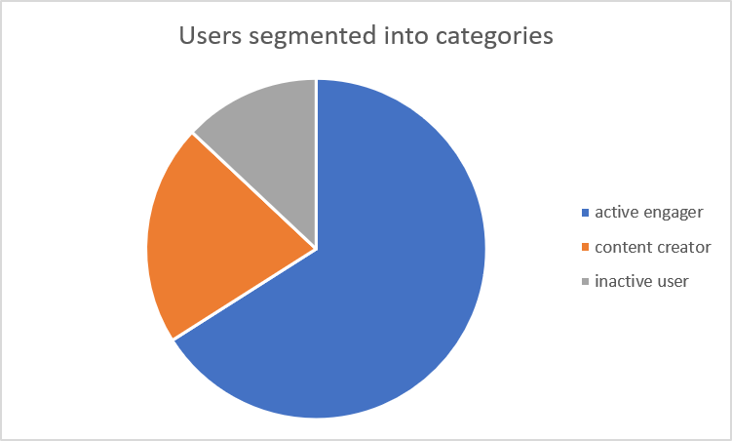

Approach:

- Users were grouped based on their posting activity and how often they interact with other users.
- Four main groups were created: Content Creators (users who post frequently), Active Engagers (users who often like or comment), Casual Users (users with limited activity), and Inactive Users (users with no posts, likes, or comments).
- This type of behavioral segmentation helps understand how different users participate on the platform.
- It also makes it easier to create marketing strategies and recommendations based on each user's activity level.

Insights:

- Content Creators produce a large amount of content and help keep the platform active.
- Active Engagers increase interaction through likes and comments, even if they do not post regularly.
- Casual Users have some level of activity but could become more engaged with the right content and recommendations.
- Inactive Users have little or no interaction and may need specific campaigns to bring them back.
- Understanding these different user groups can help the platform provide more relevant content and improve user retention.
- User behavior may change over time, so some users can move from one segment to another as their activity increases or decreases.

Recommendations:

- Reward Content Creators with badges, special features, recognition, and opportunities to collaborate with brands.
- Encourage Active Engagers to create their own content by promoting simple creation tools, challenges, and rewards.
- Keep Casual Users interested by showing personalized recommendations, trending hashtags, and interactive notifications.
- Use targeted email campaigns, push notifications, and welcome-back rewards to encourage Inactive Users to return.
- Regularly update the user segments based on their latest activity so that marketing strategies remain relevant.
- Use these segments to provide personalized experiences and improve engagement across different types of users.

- If data on ad campaigns (impressions, clicks, conversions) is available, how would you measure their effectiveness and optimize future campaigns?

Code:

with photo_engagement as (
select p.id as photo_id, count(distinct l.user_id, l.photo_id) as total_likes, count(distinct c.id) as total_comments
from photos p
left join likes l
on p.id = l.photo_id
left join comments c
on p.id = c.photo_id
group by p.id
),
hashtag_engagement as (
select t.id as tag_id, t.tag_name, sum(coalesce(pe.total_likes, 0)) as total_likes, sum(coalesce(pe.total_comments, 0)) as total_comments
from tags t
join photo_tags pt
on t.id = pt.tag_id
left join photo_engagement pe
on pt.photo_id = pe.photo_id
group by t.id, t.tag_name
)
select tag_name, total_likes, total_comments, (total_likes + total_comments) as total_engagement
from hashtag_engagement
order by total_engagement desc;

Output:
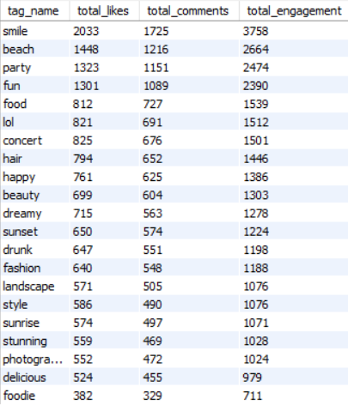

Visualization:

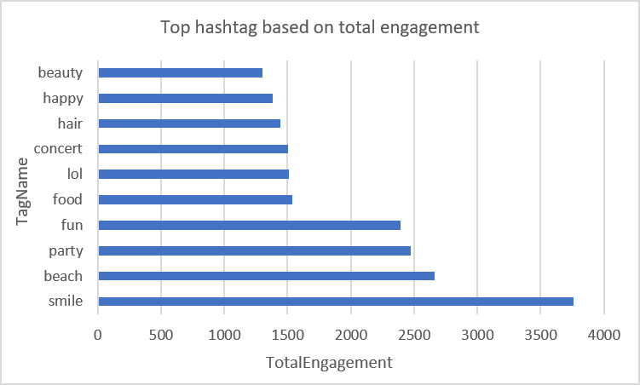

Approach:

- Since the dataset does not include advertisement campaign metrics such as impressions, clicks, or conversions, hashtag engagement was used as an alternative measure of campaign effectiveness.
- The analysis combines likes and comments received by posts associated with each hashtag to calculate total engagement.
- Hashtags with the highest engagement indicate content themes that resonate strongly with users.
- By identifying these high-performing topics, marketers can design campaigns around user interests and improve audience reach and interaction.

Insights:

- Hashtags with the highest engagement represent content categories that consistently attract user attention and interaction.
- Highly engaging hashtags can be used as indicators of audience preferences and current content trends.
- Focusing on engagement rather than only hashtag usage helps identify topics that generate meaningful interactions.
- Popular content themes can be incorporated into promotional campaigns to increase visibility and user participation.
- Monitoring hashtag performance regularly enables marketers to adapt campaigns according to changing user interests.

Recommendations:

- Prioritize high-engagement hashtags in future promotional campaigns to maximize audience reach and interaction.
- Encourage content creators to use top-performing hashtags while maintaining relevance to their posts.
- Design personalized marketing campaigns around the most engaging content themes identified through hashtag analysis.
- Continuously monitor hashtag performance to identify emerging trends and adjust marketing strategies accordingly.
- Combine trending hashtags with seasonal or campaign-specific hashtags to improve discoverability and campaign effectiveness.
- Integrate hashtag engagement insights into Instagram's recommendation system to deliver more personalized content and advertisements.

- How can you use user activity data to identify potential brand ambassadors or advocates who could help promote Instagram's initiatives or events?

Code:

with post_count as (
select user_id, count(*) as total_posts
from photos
group by user_id
),
like_count as (
select p.user_id, count(*) as total_likes_received
from photos p
join likes l
on p.id = l.photo_id
group by p.user_id
),
comment_count as (
select p.user_id, count(*) as total_comments_received
from photos p
join comments c
on p.id = c.photo_id
group by p.user_id
)
select u.id, u.username, coalesce(pc.total_posts, 0) as total_posts,
coalesce(lc.total_likes_received, 0) as total_likes_received,
coalesce(cc.total_comments_received, 0) as total_comments_received,
round((coalesce(lc.total_likes_received, 0) + coalesce(cc.total_comments_received, 0))
/ nullif(coalesce(pc.total_posts, 0), 0), 2) as engagement_per_post
from users u
left join post_count pc
on u.id = pc.user_id
left join like_count lc
on u.id = lc.user_id
left join comment_count cc
on u.id = cc.user_id
where coalesce(pc.total_posts, 0) > 0
order by engagement_per_post desc, total_posts desc;

Output:

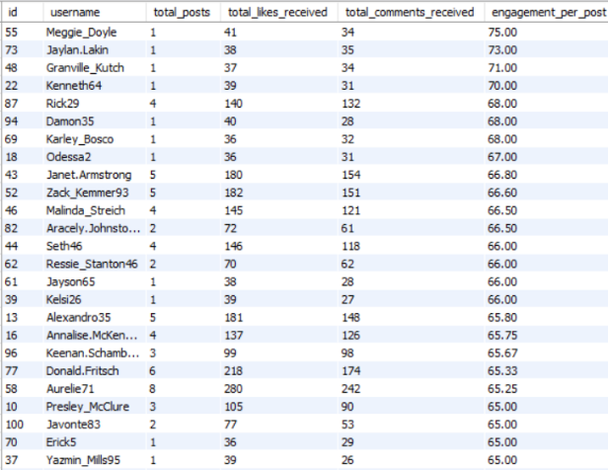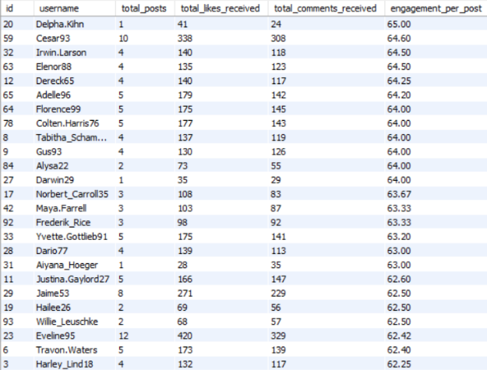

Visualization:

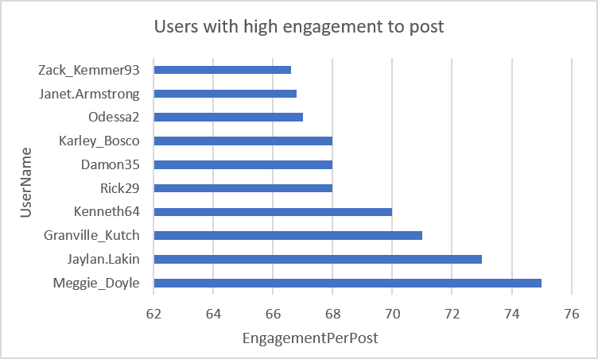

Approach:

- Potential brand ambassadors were selected by looking at user activity, posting consistency, and engagement on their content.
- Users who regularly create posts and receive a good number of likes and comments were considered strong candidates.
- Engagement per post was used as an important metric because it shows how well a user's content connects with their audience.
- Users who consistently post quality content and maintain strong engagement are more likely to influence other users and support the platform.
- This approach helps identify users who can represent the brand through genuine interaction rather than only focusing on follower numbers.

Insights:

- Users with consistently high engagement can have a strong influence on their audience and encourage more platform activity.

- Regular content creators help keep their communities active by continuously sharing new content.

- High engagement can indicate that users have a good connection and level of trust with their audience.

- A brand ambassador does not always need to have the highest follower count; consistent activity and quality engagement are also important.

- Identifying these users can help strengthen the community and encourage more authentic promotion of the platform.

- Users who maintain strong engagement over time may be more valuable than users who experience only a short-term increase in popularity.

Recommendations:

- Invite high-performing users to join a Brand Ambassador Program and provide them with special recognition.
- Offer benefits such as creator badges, early access to new features, exclusive events, and other rewards.
- Encourage ambassadors to create educational posts, promotional content, and community challenges.
- Build long-term partnerships with users who consistently perform well instead of selecting ambassadors based on one-time results.
- Regularly monitor ambassador performance using likes, comments, engagement rate, and posting activity.
- Encourage ambassadors to share genuine experiences and communicate with their followers to build trust.
- Provide additional support and creative resources to successful ambassadors so they can create better content and reach a wider audience.

- How would you approach this problem, if the objective and subjective questions weren't given?

Approach:

- If the project objectives were not given, the first step would be to understand the business problem and explore the available data.

- The dataset would be reviewed to understand the main tables, relationships, user activities, and possible data quality problems.

- After checking for missing values and duplicate records, Exploratory Data Analysis (EDA) would be performed to study user behavior, posting activity, engagement, followers, and hashtag usage.

- Based on the findings, important KPIs would be selected, SQL queries would be created, and visualizations would be used to present the results clearly.

- The final step would be to provide useful recommendations that can help the business make better decisions.

Insights:
- Clearly understanding the business goal is important before starting any data analysis.

- Exploring the dataset first helps identify useful patterns, relationships, and possible data issues.

- Selecting the right KPIs keeps the analysis focused on important business goals.

- Visualizations make the results easier to understand and help stakeholders see important trends.

- Following a proper step-by-step process can make the analysis more accurate and useful.

- A structured approach also helps ensure that the final recommendations are based on actual data.

Recommendations:

- Start every analytics project by clearly understanding the business requirements and expected outcomes.

- Clean and validate the data before performing detailed analysis to avoid incorrect results.

- Use EDA to discover useful trends and patterns before creating final business questions.

- Select KPIs that match the main business goals, such as engagement, retention, and user growth.

- Use simple and clear visualizations to present important findings to stakeholders.

- Provide practical recommendations based on the analysis so that the results can support business decisions.

- Review and update the analysis regularly as new data is added and business requirements change.

- Assuming there's a "User_Interactions" table tracking user engagements, how can you update the "Engagement_Type" column to change all instances of "Like" to "Heart" to align with Instagram's terminology?

Code:

update user_interactions
set engagement_type = 'heart'
where engagement_type = 'like';

Approach:

- The objective is to standardize the terminology used for user interactions by replacing every occurrence of "Like" with "Heart" in the Engagement_Type column.

- The SQL UPDATE statement is used to make this change directly in the table.
- The WHERE condition ensures that only records with the value "Like" are updated, while other engagement types remain unchanged.
- This type of update helps keep the database terminology consistent across the application and reports.
- Standardizing these values also makes future analysis and reporting easier.

Insights:

- Using the same terminology throughout the database helps improve data consistency and accuracy.

- Standardized engagement names make dashboards and reports easier to understand.

- Using SQL to update the records is faster and more reliable than changing each record manually.

- The WHERE clause helps avoid changing records that should remain unchanged.

- Consistent naming also makes it easier for technical teams and business users to understand the data.

- Clean and standardized values can reduce confusion when the data is used for future analysis.

Recommendations:

- Always create a backup before making large or important changes to database records.

- Use a SELECT query first to check which records will be affected before running the update.

- Use a transaction when possible so the changes can be reversed if an unexpected issue occurs.

- Set clear naming rules for engagement types to keep future data consistent.

- After completing the update, run another SELECT query to confirm that the correct records were changed.

- Keep documentation of important database updates so future users and analysts can understand what changes were made.

